Hailey Integration – Use Case Document
Sep 28, 2026

Overview
Keeps Quinyx (workforce scheduling) in sync with Hailey HR (system of record). Hires, salary changes and leavers in Hailey create, update or deactivate the employee and agreement in Quinyx. A separate endpoint pushes finance dimensions to Visma.
- HaileyWebhook (WebHook/): receives Hailey events, fetches employee/company data, classifies the change, forwards it.
- HaileyIntegration_Tech (root): maps payloads and calls Quinyx / Visma.
Both are Azure Function apps (.NET isolated). A Logic App ARM template (infrastructure/logic-app/workflow.json) describes a 6-hourly batch calling /api/employees/filter, which does not exist in the code.

Systems
System | Role | Access
Hailey HR | Source of truth, sends webhooks | REST, HaileyApiKey
HaileyWebhook | Classify and route events; nightly leaver sweep | HTTP (function key) + timer
HaileyIntegration_Tech | Map and sync | /api/sync/..., function key
Quinyx | Employees, agreements, salaries, employment rates | SOAP/REST, QuinyxApiKey
Visma | Finance dimensions | REST, Visma:BearerToken
Onboarding Logic App | Called per new hire | NewEmployeeLogicAppUrl

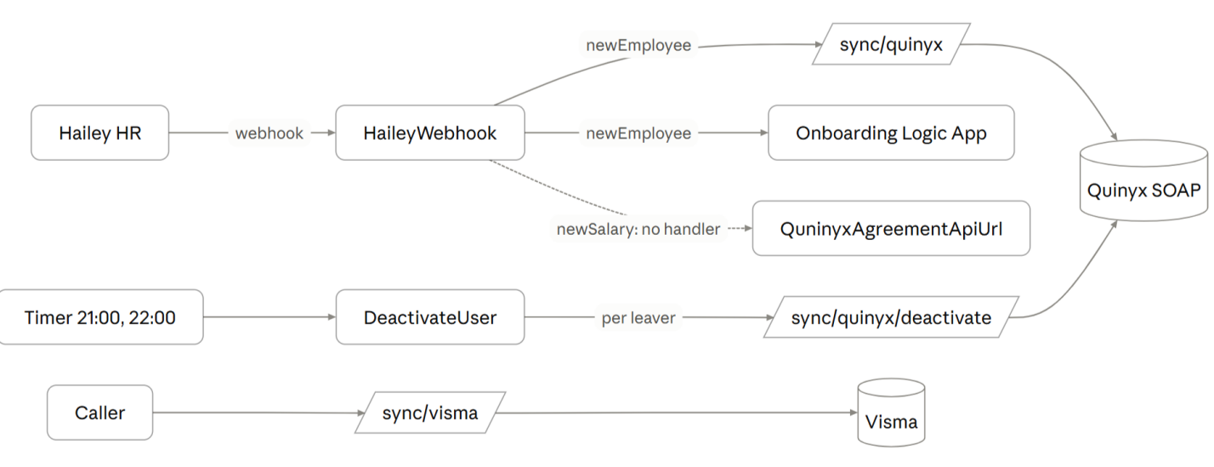

Data mapping
Join key: Hailey employment number = Quinyx badgeNo.
Quinyx field | Hailey source / rule
badgeNo, email | employmentNumber, companyEmail (required)
givenName, familyName, dateOfBirth, address | personal.*
socsecNo | personalIdentityNumber, non-alphanumerics stripped
sex | male 0, female 1, other 3
reportingTo | manager's employment number (required)
employedDate / leaveDate | dateOfJoining (required) / lastDayOfEmployment
extSectionId | own department name, only when parent dept was tried
Agreement templateId | last salary record's type: hourly → "tim", full-time → "heltid", monthly → "deltid"
salariesAdd | last salary record, latest history amount + date (hourly or monthly)
hourly | salary type = hourly (always sent)
fullEmploymentHrs | current employment's scopePercentage, for hourly and monthly (hourly used to be 0)
employmentRatesAdd | rate = scopePercentage × 100, from current employment's startDate
Agreement fromDate / toDate | dateOfJoining / lastDayOfEmployment

